**Assignment no 3:**

Create 3 repositories having 3 index.html file one in each repository.

You have httpd server installed on your server.

Now whenever you push any changes to any repository the index.html of that particular repository will be deployed on httpd server.

**Step1 :** Crated 3 repositories as repo1, repo2 and repo3

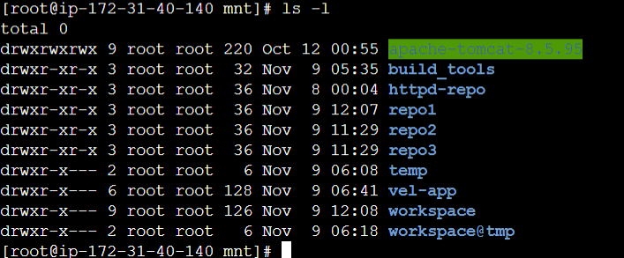

**Sep 2:** Also created 3 different GitHub repositories as repo1, repo2 & repo3

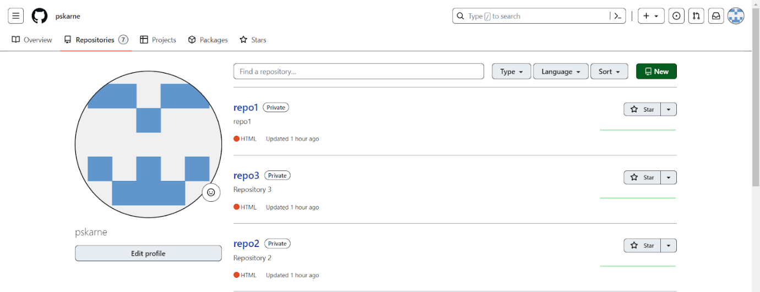

**Step 3:** Created 3 jobs in Jenkins as repo1-job1, repo2-job2, repo3-job3.

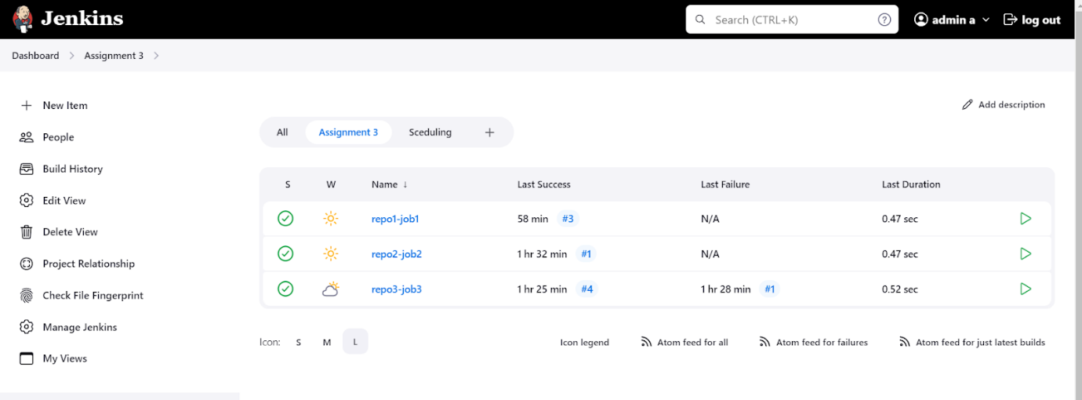

**Step 4:** each job has below properties:

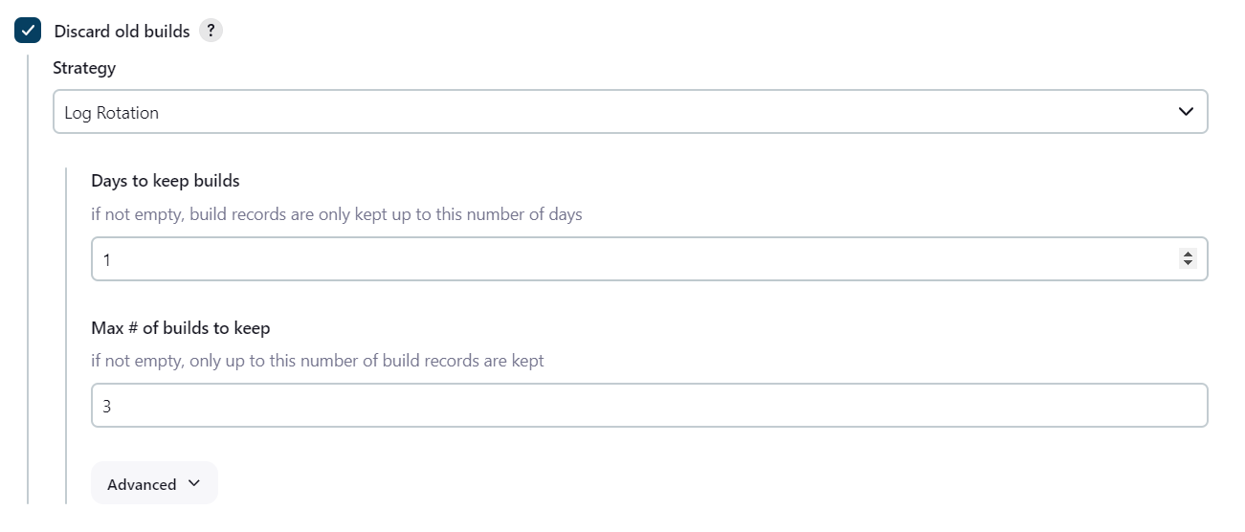

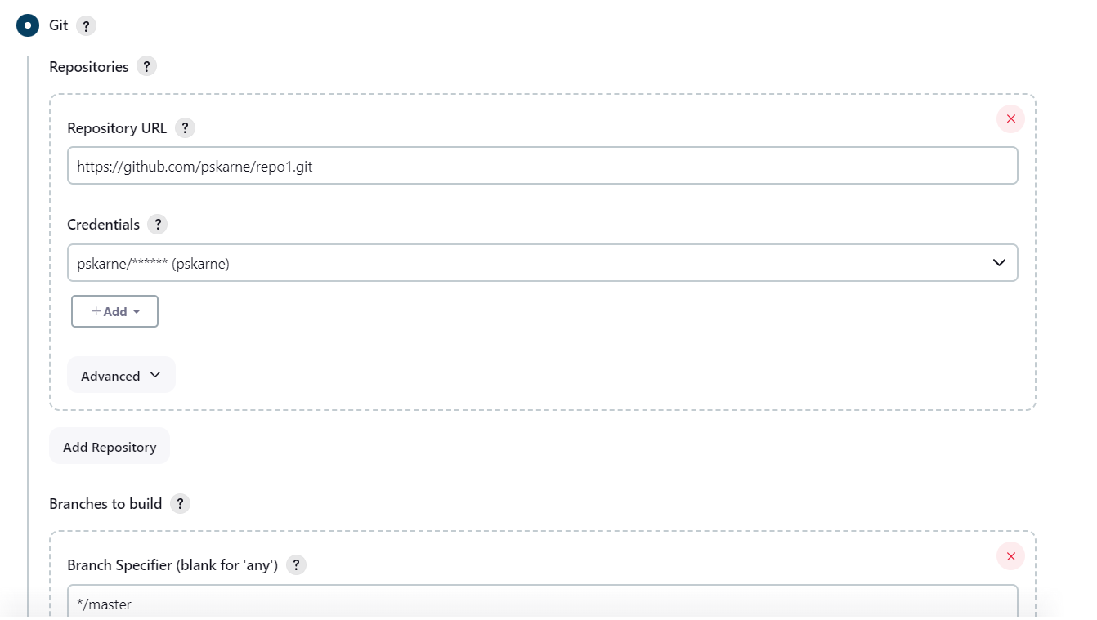

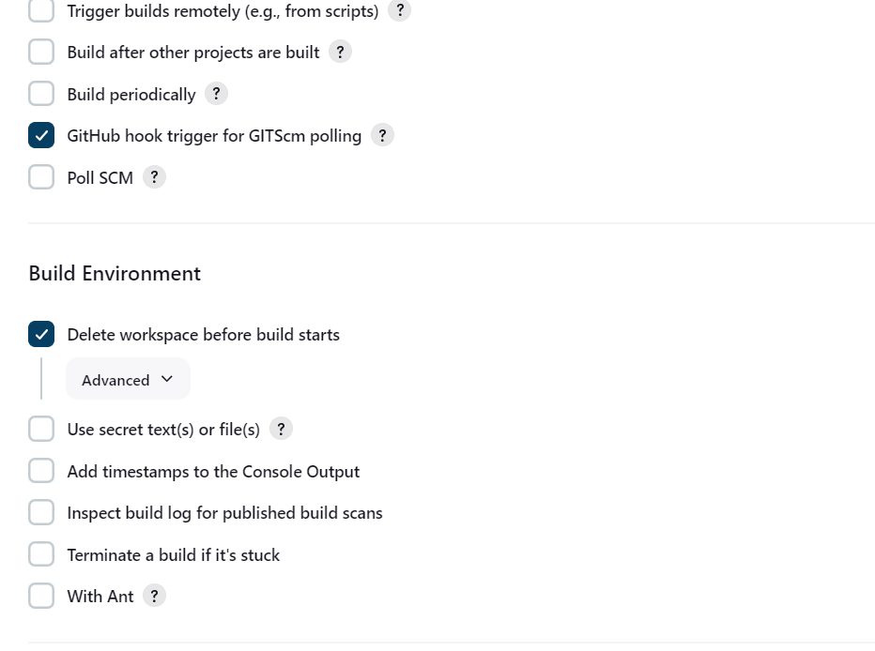

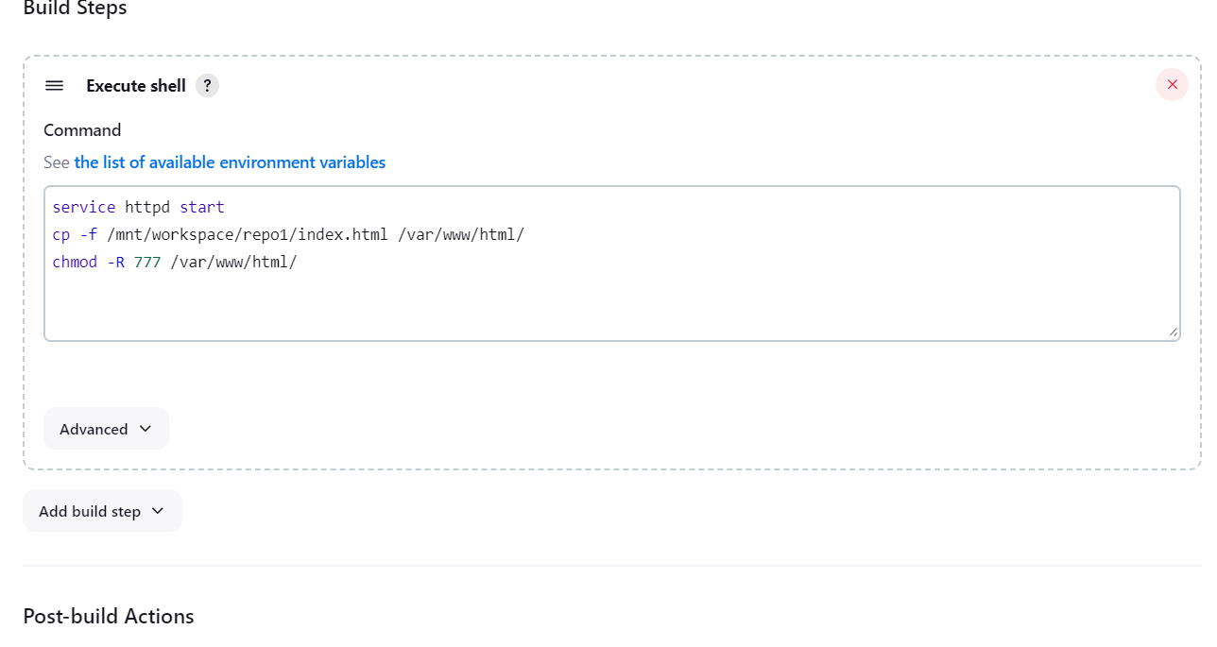

**Step 4:** Configured GitHub server - using secret text

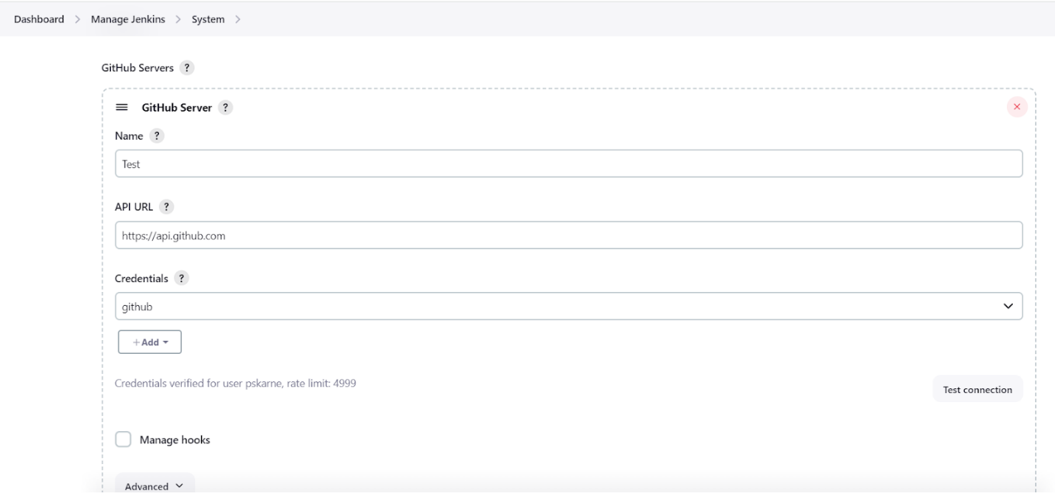

**Step 5:** on GitHub repository added a webhooks for all three repos:

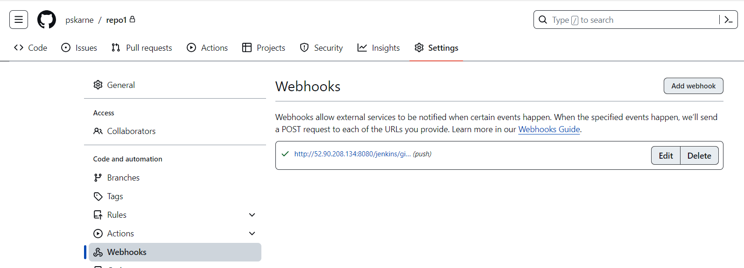

**Step 6:** Testing

All three jobs are executing successfully:

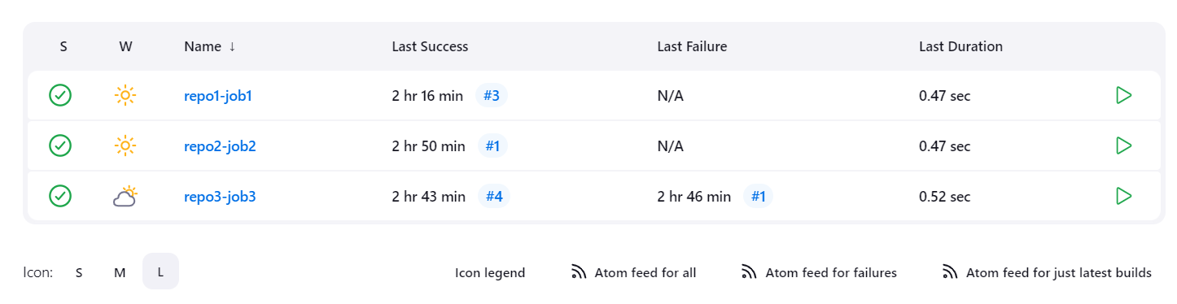

After triggering first job:

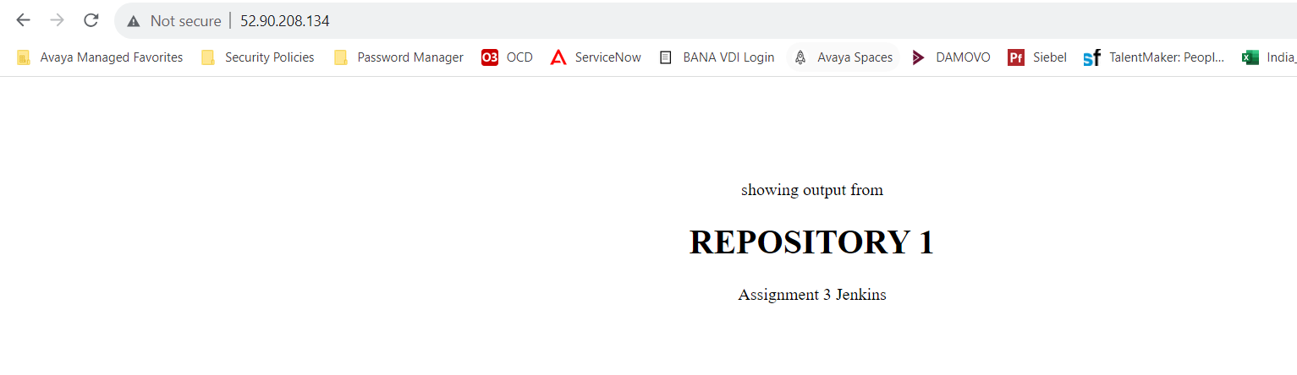

After triggering first job:

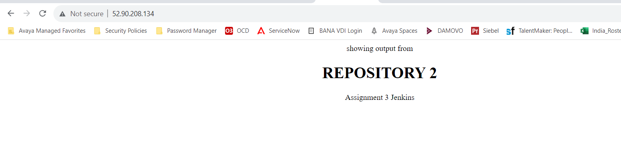

After triggering third job:

